Assignment 3 · Defect Log
Defect Log
Six confirmed defects and two investigated findings, from testing the FinServe Retail and Insurance Order Entry demo platforms.
Every entry was reproduced deliberately before being recorded. Each confirmed defect is covered by at least one automated test that fails against it, and those tests are left failing on purpose so that a fix turns them green with no change to the suite.
Two entries carry the status Not a defect. Both initially presented as application faults and were only separated by investigation. They are recorded rather than deleted because distinguishing them took work, and because reporting either as an application defect would have undermined the rest of the log.
The defect log template was not provided among the assignment inputs, so this log follows the field list set out in section 6 of the Submission 3 learner guide.

DEF-01 Portfolio API reports a total 999.00 higher than the sum of its own holdings
Module / Screen | FinServe Retail — Portfolio and /api/portfolio
Severity | High
Priority | P1
Status | Open
Test case | FS-33
Preconditions and test data
User qauser@finserve.test on FinServe Retail, port 8082. The customer holds four mutual fund positions: FOL-QA-001, FOL-QA-002, FOL-0004-FSMID003 and FOL-0004-FSDIV012. API key qa-demo-token-123 supplied in the X-API-Key header. No defect flag is exposed in the interface for this behaviour.
Steps to reproduce
- Sign in as qauser@finserve.test
- Open /portfolio and note the Current Value
- Add up the Current Value column across all four holdings
- Call GET /api/portfolio with the X-API-Key header
- Read reported_portfolio_total and sum_of_holding_values from the response
- Compare all three figures
Expected result
All three agree. A portfolio total is the sum of the holdings it summarises.
Actual result
reported_portfolio_total is exactly 999.00 higher than sum_of_holding_values, and both appear in the same response. The portfolio page shows the correct figure. Observed at totals of 67,005 / 77,005 / 87,005 / 102,005 / 132,005 with the gap constant at 999.00 each time, which rules out rounding.
Business impact
reported_portfolio_total is the customer’s net worth figure. Any system consuming this endpoint receives an inflated total while the website shows the correct one, so the two channels disagree about a customer’s money. Which systems read this field could not be determined from black-box testing, so the actual exposure depends on API usage not visible from the application under test. Reconciliation and reporting would both be affected.
Evidence

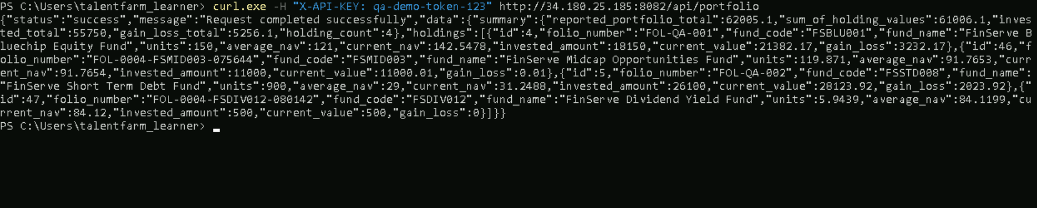

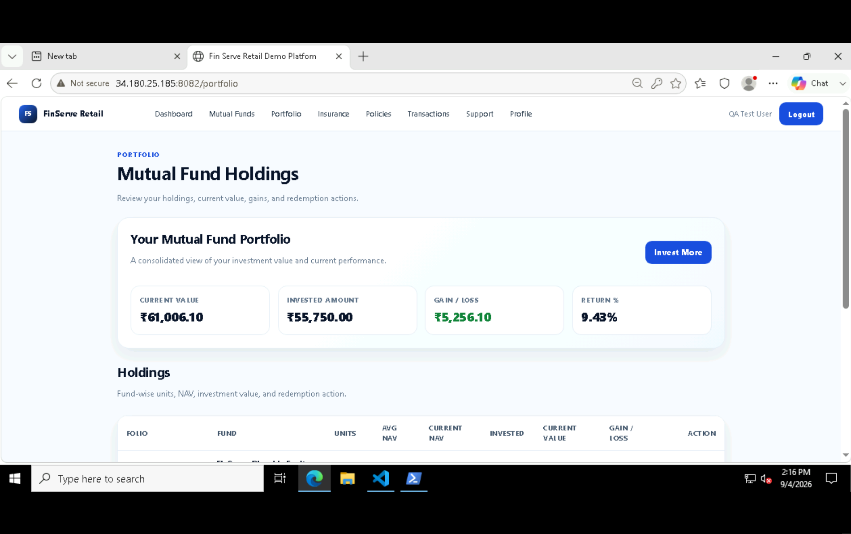

DEF-02 Failed payment transaction displayed as SUCCESS
Module / Screen | FinServe Retail — Transactions
Severity | High
Priority | P1
Status | Retest needed
Test case | FS-12
Preconditions and test data
User qauser@finserve.test on FinServe Retail. Transaction history containing the seeded record TXN-QA-FAIL-001, transaction_type Failed Payment. API key supplied in the X-API-Key header. No defect flag is exposed in the interface, but the behaviour changed between runs with no code change, so it appears to be toggled server-side.
Steps to reproduce
- Sign in as qauser@finserve.test
- Call GET /api/transactions and locate TXN-QA-FAIL-001
- Note its status field in the response
- Open /transactions and search for the same reference
- Compare the status shown on screen against the status in the response
Expected result
The status is identical in both channels.
Actual result
The API reported status FAILED. The transactions screen displayed SUCCESS, rendered in the green success style. Reproduced consistently in earlier runs; had reverted to agreement by the final run.
Business impact
A customer reading their transaction history is told a payment succeeded when it did not. They would believe money had moved and may act on that belief, for example by not retrying a payment that never completed. Support volume and reconciliation would both be affected once the discrepancy surfaced.
Evidence

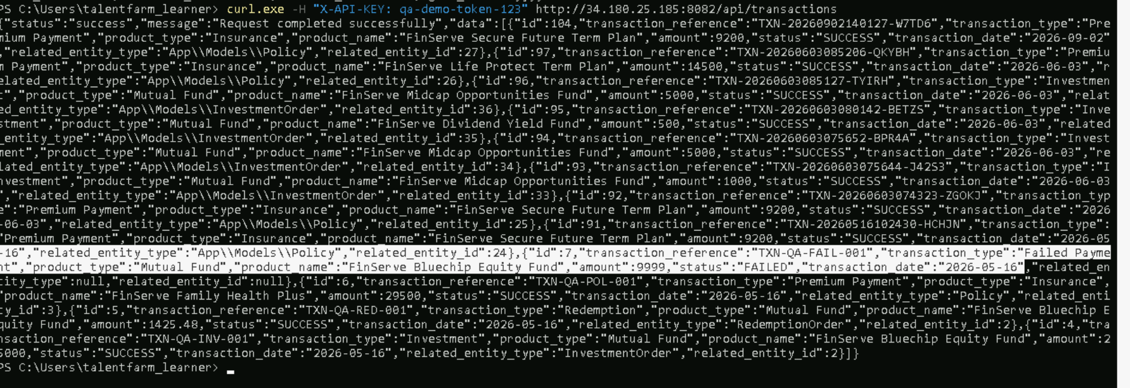
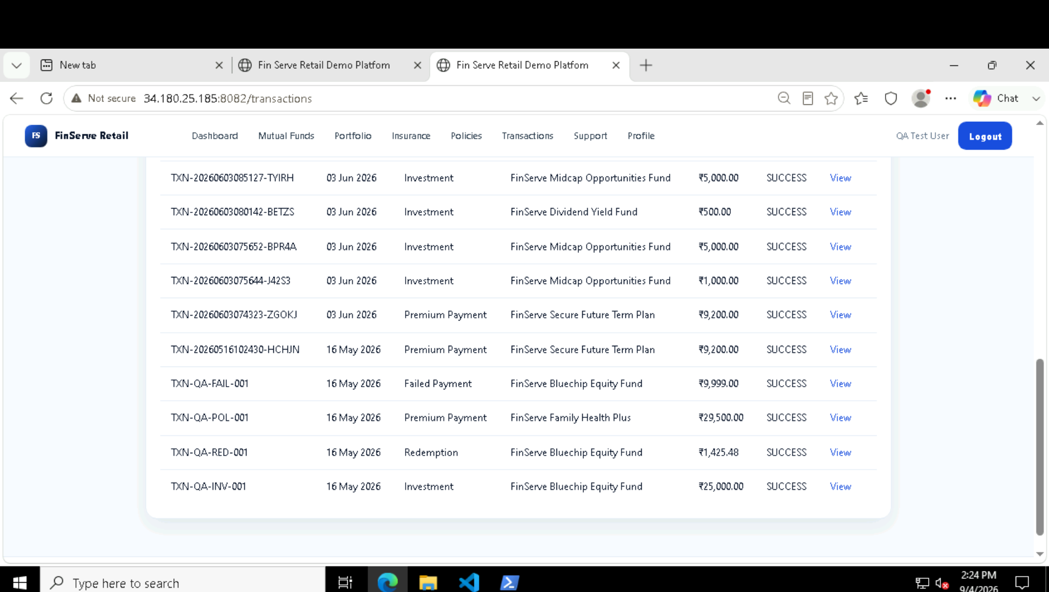

DEF-03 Insurance eligible age range is published but not enforced at purchase
Module / Screen | FinServe Retail — Insurance Purchase
Severity | High
Priority | P1
Status | Open
Test cases | FS-25, FS-26
Preconditions and test data
User qauser@finserve.test on FinServe Retail. Product FSLIFE002, FinServe Secure Future Term Plan, published with an eligible age of 18 to 55 years. The values eligibility_age_min 18 and eligibility_age_max 55 are held on the product record. Dates of birth used give ages of 56 and 17 as of the test date. No defect flag is exposed.
Steps to reproduce
- Open /insurance/2 and note the stated Eligible Age of 18 to 55 years
- Click Buy Insurance
- Enter a date of birth giving an age of 56
- Complete the nominee details and accept the declaration
- Submit the purchase
- Repeat steps 2 to 5 with a date of birth giving an age of 17
- Open /policies and check both
Expected result
Applicants outside the published eligible age range are refused and no policy is created.
Actual result
Both purchases completed. The confirmation read Policy Created Successfully in each case, and both policies appear in /policies with status Active.
Business impact
Policies are issued outside the product’s own eligibility terms. A policy sold to a minor is not a binding contract, so premiums would be collected for cover that could be void at the point a claim is made. For the over-age case, the insurer is on risk for a life it never agreed to underwrite. Both are compliance exposures rather than display faults.
Evidence

Screenshot pending. The original failure is recorded in the attached Playwright report.

Screenshot pending. The original failure is recorded in the attached Playwright report.The policies list showing both Active policies created outside that range

DEF-04 Wizard Continue controls bypass step validation
Module / Screen | Insurance Order Entry — Application Workflow
Severity | Medium
Priority | P2
Status | Open
Test case | OE-12
Preconditions and test data
Registered agent on Insurance Order Entry, port 8081. A draft application with one or more incomplete steps. No defect flag is exposed; the behaviour follows from the markup, where Continue controls are anchor elements rather than form submit buttons.
Steps to reproduce
- Sign in as an agent and open a draft application
- Navigate to the documents step without uploading anything
- Confirm the uploaded documents table shows No documents uploaded
- Click Continue to Review
- Run validation on the review step
Expected result
Progress is blocked until the step is complete, or the review step reports the missing documents.
Actual result
The application moves to the review step, and validation reports no blocking errors. Every Continue control in the wizard is an anchor link rather than a validated form submission, so no server-side check runs on navigation.
Business impact
An agent can work through the entire wizard entering almost nothing, and the sequence gives false confidence that each step was accepted as it was completed. An application can reach submission with no supporting documents at all, which underwriting would then have to chase.
Evidence

PASTE SCREENSHOT HERE
The documents step showing no uploads, and the review step reached immediately afterwards

DEF-05 Beneficiary allocation below 100% is never validated and the application can be submitted
Module / Screen | Insurance Order Entry — Beneficiaries and Review
Severity | High
Priority | P1
Status | Open
Test cases | OE-08, OE-11, OE-14, OE-15
Preconditions and test data
Registered agent on Insurance Order Entry. Application 49, a draft with client, address, KYC and product steps completed so that no unrelated validation error masks the result. One primary beneficiary, type Individual, relationship Spouse, allocation 60%. No defect flag is exposed.
Steps to reproduce
- Sign in as an agent and open the application
- Go to the beneficiaries step and note the allocation summary reads 0.00%
- Add one primary beneficiary with an allocation of 60 and save
- Confirm the summary now reads Primary allocation: 60.00%
- Complete the remaining steps so no other validation error is outstanding
- Open the review step and click Run Validation
- Click Submit Application
Expected result
Validation reports that primary allocation must total 100% and submission is refused.
Actual result
Validation returned Application validation passed and No blocking validation errors found. Submit Application was enabled and the application was submitted successfully with reference WL2026090364621, carrying an allocation of 60%. The rule is not enforced at the beneficiary step, at review, or at submission.
Business impact
An application enters underwriting with 40% of the death benefit unassigned. At claim time that share has no named recipient and would fall to the estate or be disputed, which is precisely the outcome that naming beneficiaries exists to prevent.
Evidence

PASTE SCREENSHOT HERE
The beneficiaries step showing Primary allocation 60.00%

PASTE SCREENSHOT HERE
The review step reporting no blocking validation errors

PASTE SCREENSHOT HERE
The dashboard showing WL2026090364621 with status SUBMITTED

DEF-06 Calculated age is one year higher than the date of birth implies
Module / Screen | Insurance Order Entry — Client Information and Review
Severity | Medium
Priority | P2
Status | Open, needs characterising
Test case | OE-16
Preconditions and test data
Registered agent on Insurance Order Entry. An application with the client step completed. Date of birth 01/04/1980, test date 3 September 2026. No defect flag is exposed.
Steps to reproduce
- Sign in as an agent and open an application
- On the client step, set the date of birth to 01/04/1980
- Save and continue
- Open the review step
- Read Calculated Age in the application snapshot
Expected result
Calculated Age is 46. The birthday falls in January and had passed by the test date.
Actual result
Calculated Age shows 47. A separate date of birth of 1985-06-15 produced 41, which is correct, so the error appears conditional rather than universal. A leap-year or day-boundary cause is possible: 1980 is a leap year, 1985 is not.
Business impact
Age drives the eligible age check and, on many life products, the premium band. An off-by-one means an applicant at either boundary is accepted or refused wrongly, and any age-based rate is applied from the wrong band.
Evidence

PASTE SCREENSHOT HERE
The client step showing the date of birth, and the review snapshot showing Calculated Age 47

Investigated and classified as not defects
Both of the following initially presented as application faults. They are recorded because distinguishing them from genuine defects took investigation, and because reporting either as an application defect would have undermined the rest of this log.
DEF-07 Dashboard tile counts appeared not to match the application list
Module / Screen | Insurance Order Entry — Agent Dashboard
Severity | Low
Priority | P3
Status | Not a defect
Test case | OE-05
What happened
An automated check reported that the applications list contained zero drafts, against a visible table of thirteen rows. On investigation the test was reading a table locator scoped to the dashboard’s test id, which does not exist on the applications page. Counting manually confirmed the tiles were correct. The locator was corrected and the check now passes.
Why it is recorded
It presented as a summary reconciliation defect of the same kind as DEF-01. Reporting it as an application defect would have been wrong.
DEF-08 Trust beneficiary validation appeared inconsistent between runs
Module / Screen | Insurance Order Entry — Beneficiaries
Severity | Low
Priority | P3
Status | Not a defect
Test case | OE-07
What happened
A check on trust beneficiary validation passed in some runs and failed in others. On investigation the application it targeted had been submitted and could no longer accept new beneficiaries, so the save was refused for an unrelated reason. Pointing the same check at a draft produced the expected validation errors. Trust field validation works correctly.
Why it is recorded
The intermittent result initially resembled a seeded defect being toggled, which was happening elsewhere in the same session. Only investigation separated the two.

Summary
Six confirmed defects: four high severity and two medium. Three on FinServe Retail and three on Insurance Order Entry. Five are open; one is marked for retest because it stopped reproducing before the final run.
Three of the four high severity defects share a shape worth noting. Each is a rule the application holds in its data, displays to the user, and then does not apply: the insurance eligible age range, the beneficiary allocation total, and the portfolio total. That pattern suggests validation was specified and displayed but not implemented, rather than implemented incorrectly.
Seeded behaviour appears to be toggled server-side during a session, so this log describes the environment at the time of testing rather than a fixed state. Any retest should begin by establishing which behaviours are currently active.

